**Leader Overview**

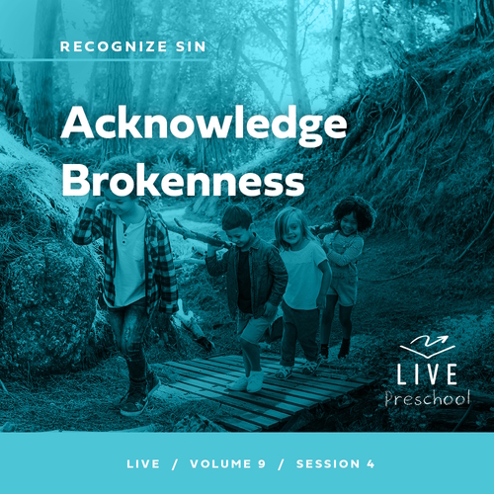

**Volume Overview**

**Recognize Sin**

*The Bible has a lot to say about sin and forgiveness. It acknowledges the deep brokenness of this world and our individual life. It is only by understanding the depth of human sin that we can understand the remarkable work of God’s forgiveness. Because of His forgiveness, we escape the eternal consequence of our sin and can rightly respond to the call to live a holy life. We learn to receive forgiveness, put off sin, and show forgiveness to those who have sinned against us. We learn to pursue holiness in the midst of the world’s brokenness.*

**Session Overview**

**Acknowledge Brokenness**

*In this* **Live** *session, preschoolers learn to trust in the plan God has for them. Life won’t always be easy, but they can know that God is good. Through the story of Jesus telling the man who couldn’t see to go wash in the pool, kids will discover that Jesus notices and cares about the things they need from Him.*

**Bible Lesson**

A Man Born Blind Is Healed

[John 9:1–41](https://ref.ly/logosref/Bible.Jn9.1-41)

**Faith Fact**

I can trust God’s plan.

**Faith Verse**

[2 Corinthians 5:17](https://ref.ly/logosref/Bible.2Co5.17) (NLT)

Anyone who belongs to Christ has become a new person. The old life is gone; a new life has begun!

**Preparing for the Session**

**Leader Preparation Time: 20–25 Minutes**

|  |
| --- |
| ***You Will Need***  ***Preservice Activities***  *• Toys*  *• Blocks or dominoes*  *• Small toy car*  *• Multicolored candies or ring cereal (M&M’s®, Skittles, etc.)*  *• Paper plates, one per kid*  ***Large Group***  *• Bible*  *• Worship songs (Song suggestions: “Never Be Shaken” by Shout Praises Kids; “King of Me” by Rend Co. Kids; “Never Be the Same” by Fellowship Worship)*  *• For groups not using a phone or tablet only, add:*  *• Projector or TV*  *• Laptop*  *•* ***Faith Fact Sound*** *video (bell ringing)*  ***• Faith Fact Slide***  *•* ***Faith Verse Slide***  *•* ***Faith Verse Video***  *•* ***Bible Lesson Video A***  *•* ***Bible Lesson Video B***  ***Small Group***  *•* ***Small Group Group Connection Page****, one per kid*  *• Crayons or markers*  *•* ***Small Group Activity Page 1****, one per kid plus one for a sample*  *•* ***Small Group Activity Page 2****, one per every four kids*  *• Scissors*  *• Brown construction paper*  *• Glue sticks, one per two kids*  *• Blindfolds, one per kid*  *• Cones or water bottles to make a path*  *• Small puzzle of ten to twenty pieces with a box, one per group because each kid will take home a puzzle piece*  *To access session content and videos from a computer, visit:* [***BibleEngagementProject.com/downloads***](https://bibleengagementproject.com/downloads) |
| ***Getting Ready***  ***Preservice Activities***  *• Set out toys and snacks.*  *• Put several snack pieces on each plate, making sure there are several of each color.*  ***Large Group***  *• Download videos and slides if needed.*  *• Select worship song(s) and have them ready to play.*  ***Small Group***  *• Print copies of the* ***Small Group Group Connection Page****, one per kid.*  *• Print copies of the* ***Small Group Activity Page 1****, one per kid.*  *• Print and cut apart the* ***Small Group Activity Page 2****, one per every four kids.*  *• For each kid, cut a piece of brown construction paper about the same size as Picture 2 from* ***Small Group Activity Page 2****.*  *• Optional: Make a sample completed activity to show the kids.*  *• Place cones randomly around the room in a path, avoiding walls or anything kids could crash into.*  *• Make a pile of puzzle pieces in front of the group but keep the box hidden.*  ***First time leading* Live *for Preschool? Check out the*** [**Facilitator Guide**](https://0b769b0ed3569ef9d18b-f88d8272f61086866d50d048b43ef630.ssl.cf2.rackcdn.com/sites/biblengagementproject/Listen_Facilitator_Guide.pdf)**.** |

**Preservice Activities**

*See what’s needed at the beginning of the session.*

**Bible Story Warm-Up**

I need everyone’s help with this activity. If you think you can help me, stomp your feet. *(Group response)* Great! I was hoping you would be excited to help me. I have a bunch of blocks, and I need your help building one long road.

• *Make sure every kid places at least one block in the project.*

Wow! This road looks good. Let’s see if we can drive a car on it. Spread out so you can help the car to move from the beginning to the end of our road.

• *Give kids the toy car to drive down the road.*

This car going down the road reminds me of you and your life. The plan for your life is more important than building a road. Of course, there’s an amazing plan for it. Who has that plan? *(Group response)* God does! There might be turns you don’t expect like when you ride in a car. The awesome news is that we don’t have to figure out the turns in life on our own. We can trust God’s plan for us even when it’s scary or hard. We’ll find out more about that today.

**Snack**

**Multicolored Snacks (M&Ms, Skittles, Ring Cereal, etc.)**

Who is ready for a yummy snack? *(Group response)* Great! I’ll hand out a plate to you, but I need you to not touch anything on it until I tell you what to do. Today, we’ll learn about trusting God’s plan for us. To do that, we need to listen to Him and follow what He says to do. Let’s practice following directions with our snack. I’ll give you detailed instructions about what to do. Then, you can eat it when we’re done.

• *Hand out a plate with candies to each kid.*

• *Give kids detailed instructions. For example, have them make a ring around the edge of the plate using colors of candies in a specified order.*

• *Watch for kids who may not know their colors yet or are color blind. Help them as needed.*

You did a great job trusting the plan that I had for this yummy snack. I know it was different than a normal snack, but you trusted me, and it turned out great for all of us. In our Bible story, we’ll learn about a man who discovered God had a special plan for his life when he met Jesus. This will be an exciting day of learning more about God from His Word.

**Free Play**

*Any extra time can be spent playing with toys.*

**Transition**

*A few minutes before service begins have kids make their way to the large group area and sit in their designated areas.*

**Large Group**

**25 Minutes**

*See what’s needed at the beginning of the session.*

**Introduction**

Friends, it makes me so happy to see you here today! I love coming here to learn about God with you. The Bible *(hold up the Bible)* has so many amazing truths for us. Today, we’ll learn about a man who couldn’t see. Guess who saw the man and helped him? *(Allow responses.)* You’re right! Jesus sees us and cares about us. Do you think Jesus cared about this man? *(Group response)* Of course, He did!

**Faith Fact**

Remembering how much God cares about us helps us trust the plan He has for us. Hey, that sounds a lot like our Faith Fact today! **I can trust God’s plan.**

• *Show the* ***Faith Fact Slide.***

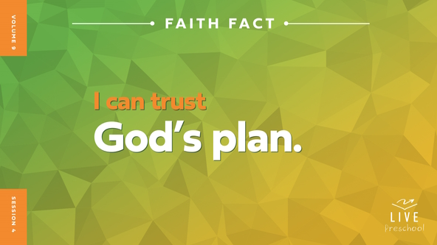

God’s plan for us won’t always be easy, but we know it will be good. Let’s give someone a fist bump while we say our Faith Fact again. **I can trust God’s plan**. Let’s do that one more time. **I can trust God’s plan**.

**Bible Time**

We can find out more about God’s plan to bring us closer to Him in the Bible. Let’s check in with Grandpa and Lizzy to see if they have a Bible story to share with us.

• *Play* ***Bible Lesson Video A****.*

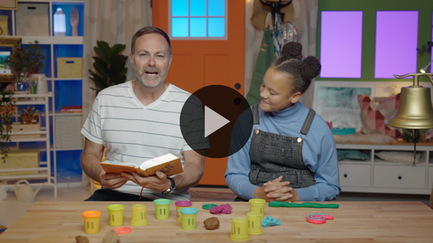

I’m glad Grandpa gave us some time to think about what happens next. We’ll take some time to worship God. Then, I’ll ask you what you think will happen next in our Bible story.

**Worship**

Jesus saw people who needed Him, and He helped them. That makes me want to show Him how much I love Him with my very best praise.

**Praise**

Who wants to thank Jesus for His love? Touch your toes down low. *(Group response)*

Are you glad we can trust God’s plan? Wave your hands up high. *(Group response)*

Who knows God wants to be close to us? Hug yourself so tightly. *(Group response)*

**Sing**

Let’s sing praise to God in the best voice we can!

• *Lead the kids in singing one or two songs. See song suggestions at the beginning of the session.*

**Prayer**

I love to hear you worshipping God. Someone else hears you when you worship. Who is it? *(Allow responses.)* Yes, God hears all of our voices, and it’s a sweet sound to Him because He loves us so much. Let’s pray.

|  |
| --- |
| *Dear God, You love everyone so much! We know we can trust Your plan for us. Thank You for the way You care about people who need You. We want to love people like You do, and we want to show them Your love. Amen.* |

**Bible Time cont’d**

Grandpa and Lizzy will be back soon! Let’s think about the answer to what happens next in our Bible story. Put on your thinking cap *(demonstrate).* Okay, did the man obey Jesus’ words and go to the pool? *(Point to the “green man” image.)* Or did he decide Jesus’ words didn’t make sense, so he stayed right where he was? *(Point to the “red hand” image.)*

If you think the man obeyed Jesus’ words and went to the pool, hold your nose like you’re jumping into the water. If you think the man didn’t obey Jesus’ words, cross your arms and make your unhappy face. Ready? Choose your answer.

• *Pause while kids respond.*

Let’s find out if you’re right! Let’s check back in with Lizzy and Grandpa.

• *Play* ***Bible Lesson Video B.***

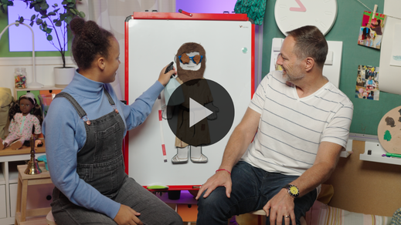

**Response Time**

*Play a worship song quietly.*

Wow! Jesus healed the man who couldn’t see. The man must have been so happy and so excited to tell his friends and family what Jesus had done! We’ll face hard things in life, but God is with us and wants to help us. Sometimes He even does miracles to help us just like He did in this Bible story. Let’s respond to the truth we’ve heard today. Let’s show God we trust His plan for us. Hold out your hands with your palms facing up *(demonstrate)*.

• *Have the kids repeat phrases of the prayer after you.*

|  |
| --- |
| *Dear God, thank You for the good plans You have for me. You love me so much. Help me to trust You with my life. You see what I need. You want to help me. You know what’s best for me. I love You. Amen.* |

**Faith Verse**

It helps us remember that God has a good plan for us when we plant His Word in our heart. Let’s practice our Faith Verse and do the actions together.

[2 Corinthians 5:17](https://ref.ly/logosref/Bible.2Co5.17) (NLT)

Anyone who belongs to Christ has become a new person. The old life is gone; a new life has begun!

• *Show the* ***Faith Verse Video.***

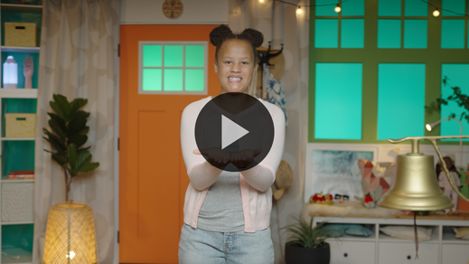

**2 Corinthians** *(hands at waist, spread apart, palms up and out)*

**5:** *(hands together like a clap)*

**17** *(hands opened to “book”)*

**Anyone who** *(point to other people)*

**belongs to Christ** *(do sign language for Jesus, middle finger to opposite palm, with each hand)*

**has become a new person.** *(spin around)*

**The old life is gone;** *(crouch low to ground)*

**a new life has begun!** *(jump with arms and feet spread wide)*

**Closing**

We’ve had an amazing time together today! We’ve explored a Bible story about Jesus healing a man’s eyes. We’ve worshipped God together, and we’ve learned a great Faith Verse. Best of all, we discovered that we can trust God’s plans for our life.

• *Play the* ***Faith Fact Sound*** *video (bell ringing).*

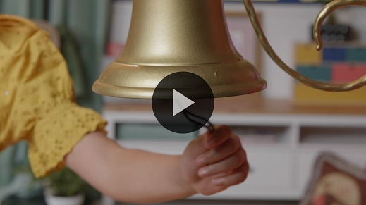

Oh, good! We have time to say our Faith Fact one more time. **I can trust God’s plan**.

• *Show the* ***Faith Fact Slide.***



Let’s use our strongest voice to say our Faith Fact because we’ll need to be strong when we trust God’s plans. **I can trust God’s plan**. Look at the friend next to you and tell them the Faith Fact. **I can trust God’s plan.**

**Dismissal to Small Groups**

Great job! Now, you get to go do some fun activities with your friends in small groups.

• *Dismiss the kids by groups.*

|  |
| --- |
| ***Leader Tip:*** *This can be done by assigning color teams or by age groups. Note that some young preschoolers may not know their age. Using a colored sticker, jersey, or wristband will help separate the kids and help identify their small groups.* |

**Small Group**

**25 Minutes**

*See supplies and prep instructions at beginning of session or in each activity below.*

|  |
| --- |
| ***Leader Tip:*** *Small groups can alternate to each circle, or all groups can do each activity at the same time. If you choose to alternate, you will need at least one leader per circle.* |

**Circle 1**

**Group Connection**

**Listen and Do**

|  |
| --- |
| ***You Will Need***  *•* ***Small Group Group Connection Page****, one per kid*  *• Crayons or markers*  ***Getting Ready***  *• Print copies of the* ***Small Group Group Connection Page****, one per kid.* |

What’s our Faith Fact today? **I can trust God’s plan.** God has a great plan for you! Do you already know everything God has planned for your life? *(Group response)* I’m older than you. Do you think I know everything God has planned for me? *(Group response)* Of course not! I need to trust God step-by-step just like you do. Let’s do an activity together to show how that works.

• *Give each kid a copy of the* ***Small Group Group Connection Page*** *and some crayons.*

When we trust God’s plan, we need to be ready to follow Him as He leads us. I’ll give you specific instructions to see if you can follow each step to finish this page. Let’s go.

• *Give kids the following instructions. Pause after each step to let kids complete it. Don’t help them unless they ask you to.*

Step 1: Draw a happy face in the circle.

Step 2: Color the star with your favorite color.

Step 3: Connect the dots to make a cross and color it red.

Step 4: Write the first letter of your name. Let me know if you need help with that.

Step 5: Color the top part of the square yellow. Color the bottom part of the square black.

Step 6: Circle the Bible if you like learning from God’s Word together.

I could see that you were trying hard to follow every step. Let’s see how you did. If you followed the instructions carefully, some parts of your page will match and some parts won’t. Show your page to the rest of the group. *(Group response)*

The same is true in our life. Some parts of God’s plan are the same for all of us. You may be wondering what would be the same for everyone. He loves us and wants us to learn about Him in the Bible. That is the same for everyone. Some parts are different. He created some of you to be boys and some to be girls. Each of you will have a different job when you grow up. You can’t just copy someone else’s plan for your life. You need to know and follow God’s plan step-by-step.

• *During the activity, interrupt and practice the Faith Fact:* **I can trust God’s plan.**

• *Play the* ***Faith Fact Sound*** *video. Review the Faith Fact even if you can’t play the sound.*



**Circle 2**

**Activity Page Time**

**Blind Man Healed**

|  |
| --- |
| ***You Will Need***  *•* ***Small Group Activity Page 1****, one per kid plus one for a sample*  *•* ***Small Group Activity Page 2****, one per every four kids*  *• Scissors*  *• Brown construction paper*  *• Glue sticks, one per two kids*  ***Getting Ready***  *• Print copies of the* ***Small Group Activity Page 1****, one per kid.*  *• Print and cut apart the* ***Small Group Activity Page 2****, one per every four kids.*  *• For each kid, cut a piece of brown construction paper about the same size as Picture 2.*  *• Optional: Make a sample completed activity to show the kids.* |

In the Bible, we learned about a time when Jesus helped somebody who was blind to see for the very first time.

• *Hand out a copy of the* ***Small Group Activity Page 1*** *to each kid.*

What do you remember about our Bible story? *(Allow responses.)* So many people had questions about why this man couldn’t see, but he just trusted Jesus. Jesus healed him in a very unusual way. Jesus made mud and put it on the man’s eyes. Let’s pretend to put mud on this man’s eyes. I’ll give you another paper so that you can show what that might have been like. You’ll tear small pieces of construction paper and glue them to this smaller paper. Then, you’ll glue this smaller paper over his eyes.

• *Hand out Picture 2 from* ***Small Group Activity Page 2****, one per kid.*

• *Give kids a small piece of brown construction paper to tear into pieces and glue on Picture 2.*

• *Show kids how to fold the edge of Picture 2 and glue it on their Activity Page 1.*

Great job! Before you can tell the whole story to someone at home though, we need to add one more thing to your page. Before Jesus healed the man, he was blind. Let’s add glasses to the page so that he looks like the man Lizzy and Grandpa showed us in the video.

• *Give each kid a Picture 1 from* ***Small Group Activity Page 2.***

• *Show kids how to fold the edge of Picture 1 and glue it on top of Picture 2 on their Activity Page 1.*

Awesome! This man discovered that Jesus had a special plan for his life from the very beginning. He wasn’t blind because he or his parents had done anything wrong like the people in the story thought. God wanted to show us that He has the power to heal. We can trust God and His plan for our life, too. I hope you will tell this important Bible story to someone when you go home because God has a plan for them!

• *Optional: Practice telling the Bible story together by reading the story and showing the kids when to flip the pictures to match the story.*

**Circle 3**

**Feet-to-Floor Game Time**

**Growing Trust**

|  |
| --- |
| ***You Will Need***  *• Blindfolds, one per kid*  *• Cones or water bottles to make a path*  ***Getting Ready***  *• Place cones randomly around the room in a path, avoiding walls or anything kids could crash into.* |

We’ll play a fun game. If you want to play, clap your hands three times! *(Group response)* If you look around the room right now, you’ll see some cones on the floor. Your job is to make it from one side of the room to the other. That seems pretty easy, right? *(Group response)*

That would be way too easy! I think you can do something much harder. To make it a little more challenging, you’ll need a partner. One of you will wear a blindfold while the other person leads them through the path. When you get back, you’ll say the Faith Fact. Let’s say it together now. **I can trust God’s plan.** Good job! Let’s play!

• *Help kids put on their blindfolds when needed and play the game.*

That was amazing! Just like you trusted your friend to help you know where to go, you can trust God’s plan for your life even more!

• *Have the partners switch places and play the game again.*

**Circle 4**

**Hands-On Learning**

**Puzzle Object Lesson**

|  |
| --- |
| ***You Will Need***  *• Small puzzle of ten to twenty pieces with a box, one per group because each kid will take home a puzzle piece*  ***Getting Ready***  *• Make a pile of puzzle pieces in front of the group but keep the box hidden.* |

It must’ve been hard for the man who was born blind in the Bible story. I’m sure he had questions about why he had to be blind and why God hadn’t healed him yet. God’s plans for our life aren’t always exactly what we would choose. Sometimes it can be confusing and hard to understand what God is doing, but we can always trust His plan. Here’s what it can be like.

• *Make a pile of puzzle pieces in front of the group.*

Have you ever tried to put together a puzzle with a lot of pieces? *(Group response)* Puzzles can be hard to do sometimes. Can anyone just look at the pieces and tell me what the picture is? *(Group response)* No way! That would be so hard. I think the person who made the puzzle would know exactly where the pieces are supposed to go because they know what the picture is supposed to look like. That’s what it’s like when we trust God and His plans for us. When we trust His plans, we’re trusting that He knows exactly where the pieces of our life are supposed to go.

• *Pull out the puzzle box.*

Hey! Now we know what the puzzle maker planned for this puzzle to look like. Why don’t you each take turns helping me put it together. If we all work together, I’m sure we can finish this puzzle in no time.

• *Allow kids to assemble the puzzle as time allows.*

That was awesome! I want each of you to take home one piece of the puzzle to help you remember that you can trust God’s plan for your life.

**Dismissal**

• *Play the* ***Faith Fact Sound*** *video (bell ringing).*



• *Show the* ***Faith Fact Slide.***



That reminds me of our Faith Fact. Can you all say it with me? **I can trust God’s plan.** Awesome job! I can’t believe our time together is almost over. It’s been so much fun getting to learn more about God’s Word and play some awesome games with you. I can’t wait until we get to do it again. See you next time!

• *Send home the* ***Small Group******Activity Page*** *and puzzle piece with each kid.*

• *Remind parents that there are* ***Family Devotions*** *available on the app to do with their kid.*

• *Tell everyone the date and time for the next session.*

.